John Kane D. C..
495 Watchung Ave Bloomfield, NJ 07003
(973)338-4100 Date: __________________
Name: _______________________ Email address: _____________________

Address: ________________________ City: _________________ State: _______ Zip: _______

Home Phone: __________________ Cell Phone: __________________________________

Place of Employment: _______________________Position:
Is it best to contact you by: Email, Home phone, Cell phone
Date of Birth: ______________Age______ Single Married Divorced
# of Children_____________
Have you ever seen a chiropractor before? Y N Last Visit_______________
How were you referred to Dr. Kane? ______________________________________________
What are you most important health problems? Please list in order of importance, so that the health problems you want to address first are listed first.

- _________________________ 4. __________________________

2. ____________________________ 5. __________________________

3. ____________________________ 6. __________________________
Have you seen anyone for these complaints? Who? What was the diagnosis was treatment provided and was it helpful? __________________________________________________________________________________________________________________________________________________________________________________________________________________________________________________________________________________________________________________________________________________________________________________________________________________________________________________________________________________________________________________________________________________________________

Medications (List prescription and non-prescription drugs, dosages and the date you began taking them. Do they help? Side effects? List Supplements (List all vitamins, minerals, herbs)
__________________________________________________________________________________________________________________________________________________________________________________________________________________________________________
__________________________________________________________________________________________________________________________________________________________________________________________________________________________________________
__________________________________________________________________________________________________________________________________________________________________________________________________________________________________________
Primary care physician: ______________________Date of last physical exam? ______
Last Lab work/ Any abnormal lab findings? Y N Please bring in a copy.
Do you know your Vitamin D level? Y N __________________________________________________________________________________________________________________________________________________________________________________________________________________________________________
Reason for visit
Is this problem new? Y N When did it start?
Mark your Current Level of pain with a X Mark below on the diagram
Mark your Current Stress level with a + where your complaints are.

l_____________________________________________l
No pain Very severe pain

What makes your complaint better?_______________________________

What makes your complaint worse?_______________________________

Any numbness or tingling? Y N Where?_______________________

Does one leg/arm feel heavier or colder? Y N If yes which?
What percent of the day are you aware of your pain/complaint?
0-25% 26-50% 50-75% 75-100%

Does your complaint affect your sleep or prevent any activity? Y N
____________________________________________________________
Your Health History (Please check if you have this medical condition currently or have had in the past,

____ Alcoholism
____ Allergies
____ Anemia
____ Arthritis
____ Asthma
____ Bladder Disease
____ Cancer
____ Colitis
____ Diabetes
____ Pneumonia
____ Glaucoma
____ Tuberculosis
____ Sciatica
____ Emphysema
____ Epilepsy
____ Goiter
____ Gout
____ Heart Disease
____ Herpes
____ High blood pressure
____ Low blood pressure
____ Liver disorder
____ Psychological disorder
_____Sexual abuse or assault
____ Bronchitis
____ Cataracts
____ Severe physical injury
____ Multiple sclerosis
____ Skin disorder
____ Stroke
____ Thyroid disorder
____ Venereal disease
____ Drug addiction
____ Hemorrhoids
____ Kidney disease (stones)
____ Pancreatitis
____ Herniated spinal disk
____ Gall stones
____ Ulcers
____ Intestinal parasites
____ Autoimmune disorder
____Lyme disease

Females Only:

____ Endometriosis
____ Ovarian cysts
____ Fibrocystic breasts

____ Uterine Fibroids
____ Cervical dysplasia
____ Menstrual irregularities

Do you use tobacco? Y N How many per day?_______________________
Did you ever use tobacco? Y N For how many years?______________________
Date you quit_________________________________________________________________
Family Health History (Please note any significant medical conditions, especially cancer, heart disease, diabetes, high blood pressure, allergies, asthma, autoimmune disease, psychological disorders, thyroid disorders): Mark with X if deceased and how old they were.

Mother: ______________________________________________________________________

Father: _______________________________________________________________________

Brothers: ______________________________ Sisters: _________________________________

Grandparents: __________________________________________________________________

Children: _____________________________________________________________________

Dental History
Number of tooth extractions:_____________________________________________________
Number of root canals?________________ _________________________________________
How many silver amalgam tooth fillings do you have? ________________________________
If you have silver amalgam removed- when and how many?____________________________
Do you have regular teeth cleaning? Y N
Do you use fluoride toothpaste? Y N
Does the toothpaste or shampoo contain Lauryl Sulfate or Laureth Sulfate? Y N
Any history of injury from automobile accident, falls, broken bones? Y N Give dates
__________________________________________________________________________________________________________________________________________________________________________________________________________________________________________

Symptom Survey (If these symptoms do not apply, then leave them blank. If the symptoms apply to you, then check with the following: “1” for mild, occasional symptoms; “2” for moderate, more frequent symptoms; “3” for severe or constant symptoms.)

Chest

____ Persistent cough
____ Coughing up mucous
____ Spitting up blood
____ Wheezing
____ Difficulty breathing
____ Shortness of breath
____ Chest pain on exertion

Mouth and Throat
____ Sore throat
____ Sore tongue
____ Bleeding gums
____ Gingivitis
____ Thrush
____ Enlarged tonsils
____ Hoarseness

Neurological
____ Fainting
____ Seizures
____ Paralysis
____ Muscle weakness
____ Numbness
____ Tingling
____ Memory loss
____ Headaches/Migraine
____Tremor

Breasts
Do you self-exam? Y N
____ Lumps
____ Pain or tenderness
____ Nipple discharge

Eyes
____ Impaired vision
____ Eye pain
____ Excessive tearing or dryness
____ Double vision

Ears
____ Impaired hearing
____ Ringing in ear
____ Earaches
____ Dizziness
____ Excessive earwax

Neck
____ Lumps
____ Swollen glands
____ Goiter
____ Pain or stiffness

Musculoskeletal
____ Joint pain/stiffness
____ Bursitis
____ Tendonitis
_____Pain between shoulders
____ Low back pain
____ Muscle aches or cramps
Pain /numbness in:
____Shoulders
____Elbows
____Wrist/hand
____Hip
____Knee
____Ankle/Foot
____Swollen joints

Urinary
____ Increased frequency
____ Blood in urine
____ Dark color of urine
____ Pain during urination
____ Incontinence/bed wetting
____ Testicular pain
_____Enlarged prostate

Nose and Sinuses
____ Nose bleeds
____ Nasal stuffiness
____ Sinus infections
____ Pain or tenderness in face
____ Nasal discharge
____ Post-nasal drip

Skin
____ Psoriasis
____ Itching/dry skin
____ Varicose veins
____ Eczema
____ Boils
____ Rashes/ Hives
____ Acne
____ Bruise easily
Allergy/ Intolerance/Sensitivity
____ Pollen/Mold/Dust (circle)
____ Pet dander
____ Foods (which ones)
____ Cosmetics/perfume
____ Medications
____ Poison Ivy/Oak
____EMF Sensitivity

Carbohydrate Metabolism
____ Crave sweets
____ Irritable if a meal is missed
____ Feel tired or weak if a meal is missed
____ Dizziness when standing suddenly
____ Headache if meal is missed
____ Feel tired an hour or so after eating
____ Heart Palpitations
____ Feel shaky at times
____ Over-sensitive to sugar
____ Mood swings
____ Anxiety or nervousness
____ All symptoms worse if a meal is missed
____ Need coffee for energy
____ Sudden sleepiness
____ Irritability or quick temper
____ Headaches relieved by eating
____ Symptoms appear 1-2 hours after eating

GI
____ Abdominal cramps
____ Burping
____ Blood in stool
____ Foul smelling stool
____ Mucous in stool
____ Nausea/Vomiting/Vomiting blood
____ Poor appetite
____ Stomach bloating after eating
____ Heartburn or indigestion
____ Diarrhea
____ Constipation
____ Suspected food allergies
____ Feeling of food sitting in stomach
____ Fullness after small amount of food
How many bowl movements per day? ___

Have you traveled to another country and had an intestinal infection with diarrhea from drinking the water or eating the food? If yes, when: ______________________________
Have you gone camping and had an intestinal infection with diarrhea from drinking the water from an untreated lake or river? If yes, when: ______________________________

Female Reproductive
____ Bleeding between periods
____ Pain during intercourse
____ Painful menses
____ Heavy menstrual bleeding
____ Vaginal discharge
____ Vaginal itching or burning
____ Menopause/Hot flashes
____ PMS (circle) Crave sugar Salt Irritable Tender breasts, Cramps, Bloating, Insomnia
____ Difficulty conceiving
Type of birth control: _______

Endocrine
____ Depression
____ Dry, flaky skin
____ Fatigue
____ Poor concentration
____ Excessive coldness
____ Difficulty losing weight
____ Headaches
____ Brittle nails that break easily
____ Swelling around ankles
____ Thinning hair

Hospitalization and Surgery (Date and type of illness/surgery):
______________________________________________________________________________________________________________________________________________________________________________________________________________________________________________________________________________________________________________________________________________________________________________________________________

Special Imaging Studies (CT scans, MRI, X-rays, EKG): Give year, area & reason for test
____________________________________________________________________________________________________________________________________________________________
Approximately how many times have you taken antibiotics? _____________________________

Level of stress (With 10 high) (Circle) Reaction to Work, Family, Friends, Money, World issues? & What do you do to relax? ___________________________________________________________________________________________________________________________________________________________
Exercise: Please describe what type, duration, and how often per week:
____________________________________________________________________________________________________________________________________________________________

Energy: On a scale of “1 to 10”, “1” being the absolute lowest energy, while”10” being the absolute best energy, rate your general energy level: ___________________________________
Do you have energy fluctuations throughout the day? Y N
If yes, then at what times do you have the lowest energy? _______________________________
Current Weight: Most you have ever weighed
Do you find it difficult to maintain your ideal weight? Y N
Sleep
Do you get enough sleep? Y N How many hours/night? _____________________
Do you have trouble falling asleep? Y N Do you awaken well rested? Y N
Do you wake in the night? Y N If yes, how often? ___________________________
Do you snore or have sleep apnea? Y N If yes which.
Do maintain a normal sleep schedule? Y N
Immune:
Do you get a yearly flu shot? Y N
Have you ever had a reaction to a vaccination? Y N A blood transfusion? Y N
Do you get more than two colds a year? Y N
When you get a “cold” does it take longer than 1 week for it to resolve? Y N
Do you have any chronic infections? Y N
Frequent low-grade fevers? Y N
Cold sores or fever blisters? Y N
Have you ever had “Mono”? Y N
Have you had athlete’s foot, ringworm, or other chronic fungal infection of the
skin or nails? Y N

Have you taken prednisone or other cortisone-type drugs? Y N
If yes, when and length of time: ____________________________________________________
Women:
Have you ever experienced frequent vaginal yeast infections? Y N
If yes, how often does it occur? ______________________________________________
Have you taken birth control pills in the past? Y N
If yes, when and length of time: ______________________________________________

At what age did you have your first period? ______________________________
If you are not menstruating, when was your last period? ____________________
Do you have a regular menstrual cycle? Y N
How many days are in your cycle? _____________________________________
How many days does your period last? __________________________________
How many times have you been pregnant?__________Miscarriages?_____Abortions?_______
How many times have you given birth? ____________ ______________
Were there any birthing complications? Y N
If yes, please describe: _______________________________________________

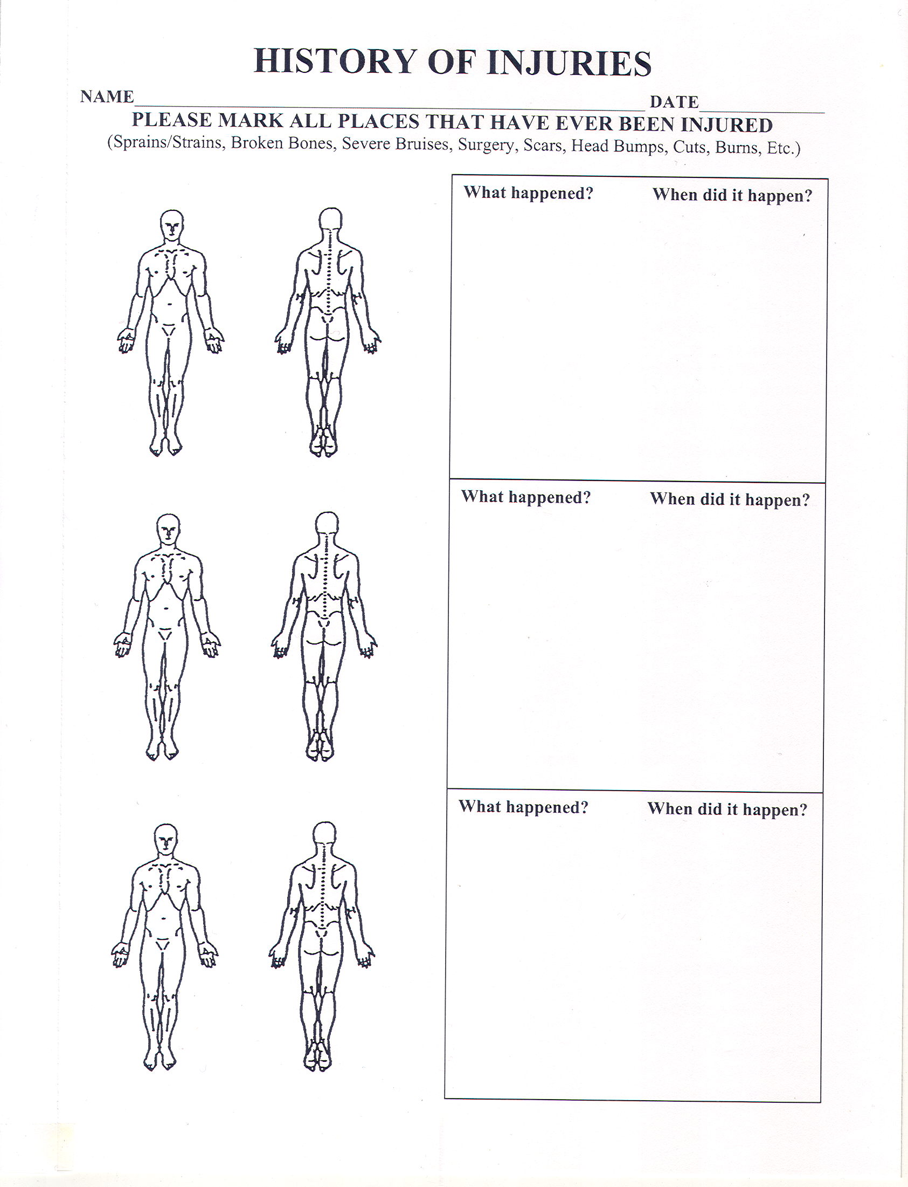

Food Record
Please list the foods that you typically eat for each meal. For example, if you eat cereal almost every day for breakfast, but only have eggs once a week, then underline the cereal and make sure to include the eggs on the list.
Breakfast:_________________________________________________________________________________________________________________________________________________________________________________________________________________________________

Lunch:____________________________________________________________________________________________________________________________________________________________________________________________________________________________________

Dinner:_________________________________________________________________________________________________________________________________________________________________________________________________________________________________________________________________________________________________________________

Snack:______________________________________________________________________________________________________________________________________________________

Dessert:_____________________________________________________________________________________________________________________________________________________
For each food class, please indicate how often you eat it. Write down whatever is most appropriate, be it once a day, 4 times a week, 3 times a day, etc….

Meat (beef, chicken, steak, turkey, ham, pork, luncheon meats, burgers): ___________________

Dairy (milk, cheese, yogurt, ice cream):______________________ Eggs: __________________

Bread: ___________________ Beans: ______________________ Fruit: ___________________

Fish (including tuna): ______________ Salads: _________________ Vegetables: ___________

Nuts and seeds (including peanut butter): _______________________ Rice: ________________

Pasta: ____________________________________ Tofu: _______________________________
Sweets (cookies, candy, cake, ice cream, etc.): ___________________ Cereal: ______________
Do you use artificial sweeteners? Daily Sometimes Rarely
Do you salt your food? Daily Sometimes Rarely
Use butter or margarine? (Circle)
What fat do you use for frying?____________________________________________________
Do you avoid GMO foods? Yes No
Which organic foods do you buy? (circle) Meats Dairy Fruit Vegetables Grains
What foods do you avoid? (Circle) Dairy Gluten Soy Nightshades Other What foods do you avoid because they disagree with you .
For the liquids, please list how many 8 ounce cups per day/week.
Water: ________________________ Juice: _______________________ Milk: _____________
Do you have a water purification system or buy bottled water (circle)?
Coffee regular or decaff (circle): ___________________Tea (type): _______________________
Alcohol: ________________ Soda: ____________________ Other: ______________________

